# 

|  |  |  |  |  |
| --- | --- | --- | --- | --- |
| Service Out Sourcing Website |  | **Background of Self-Selection**  Software Engineering |  | Team: Team Kernel  https://team-kernel-express.myshopify.com/ |

Out Sourcing Website

Innovative Application Competition for the Service Outsourcing.

Contents

1.  0
2. Introduction 2

OutSorcing 2

E-Commerce 2

Project & Team 6

1. Process of Task 15

Choose work platform 15

Research about OutSourcing Industry 19

Research about tools & technology 19

Collecting Data 19

Select Images & Brand name 19

Start coding & Testing 19

Making final documentation 19

1. Website Overview 15

Services that can get to customers using this website 15

Services that can get to Suppliers using this website 19

The cost model and feasibility analysis 19

1. Conclusion 20

Conclusion 21

# Introduction

**Outsourcing:** In business, outsourcing is an agreement in which one company contracts-out a part of existing internal activity to another company. It involves the contracting out of a business process, operational and non-core functions. The concept outsourcing came from the American Glossary outside resourcing and it dates back to at least 1981.Outsourcing sometimes, though not always, involves transferring employees and assets from one firm to another. Outsourcing is also the practice of handing over control of public services to private enterprise.

**E-Commerce:** E-commerce is the activity of buying or selling online. Electronic commerce draws on technologies such as mobile commerce, electronic funds transfer, supply chain management, Internet marketing, online transaction processing, electronic data interchange, inventory management systems, and automated data collection systems.

Modern electronic commerce typically uses the World Wide Web for at least one part of the transaction's life cycle although it may also use other technologies such as e-mail. Typical e-commerce transactions include the purchase of online books (such as Amazon) and music purchases in the form of digital distribution such as iTunes Store, and to a less extent, customized/personalized online liquor store inventory services. There are three areas of e-commerce: online retailing, electric markets, and online auctions. E-commerce is supported by electronic business.

**Our project and Team:** We made our project for innovative application competition for the service outsourcing of college students in Zhejiang Normal University in March 2018.We made an E-Commerce website for the competition. Our team:

1. ALI IRUFAAN- 201532120135(Project manager)

2. Laincky(Customer relationship manager)

3. Md Mehedi Hasan(Technical manager)

4. Ricil Banks(Developer)

5. Klaus(Developer)

**Process Of our Task:**Whole task we did by a process. At first we chose a platform to do this task. Then we did relative researches about the outsourcing industry and other information. Following that we select tools as well as data collection, brand name selection and so on. Our whole process of the task in broadly is given below.

**Platform:** To perform the task we used GitHub. GitHub is a web-based hosting service for version control using Git. It is mostly used for computer code. It offers all of the distributed version control and source code management functionality of Git as well as adding its own features.

Advantages of using GitHub:

1. It makes it easy to contribute open source projects.

2. By using GitHub, it makes easier to get excellent documentation.

3. Showcase your work.

4. Markdown.

5. GitHub is a repository.

6 .Track changes in your code across versions.

7. Integration options.

**Research about outsourcing industry:** At first we research about outsourcing industry to get a clear view about outsourcing and how this industry operates in the market. Nowadays outsourcing industry is so much competitive like other industries. In every competitive industries research is a very important thing. Business market research is the process of collecting data to determine whether a particular product/service will satisfy the needs of our customers. With effective market research, we can gain invaluable information about our competitors, economic shifts, demographics, the current market trends and the spending traits of customers. In today’s online marketing world, owning a website is very crucial for success of any business. A website meets with multiple objective of the business owner. With a website we can not only let people know about our presence in market, but can also increase our earnings and revenue by attracting more customers. To get all these benefits and to cope up with the comprehensive online market we decide ourselves to make a website.

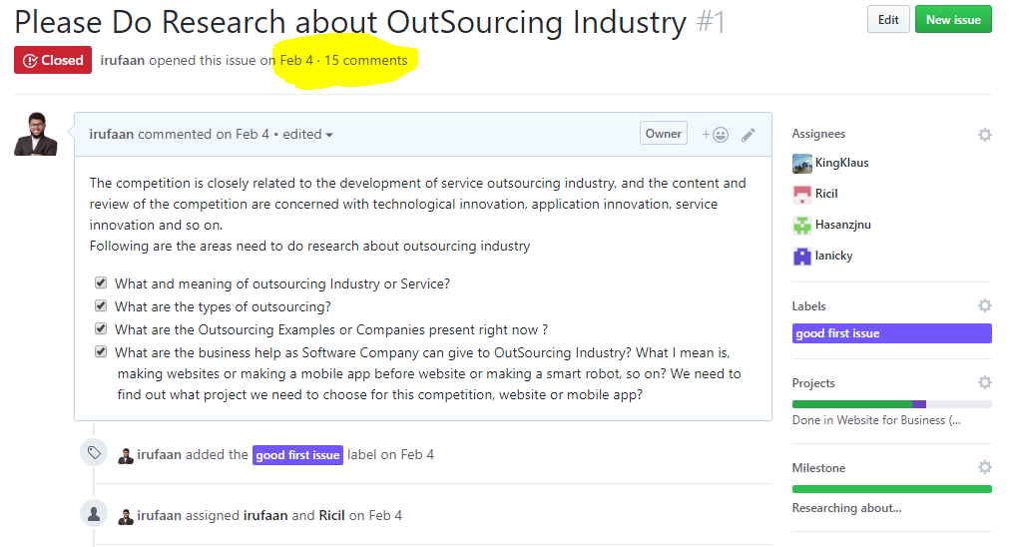

**Tools selection:** It is very important to select the accurate tools for building a software project. We research about all the tools such as server, hosting, framework, plugins that we need to build the website. After research our every team member recommend some of their opinion and then we together select the tools which is perfect for us and our work.

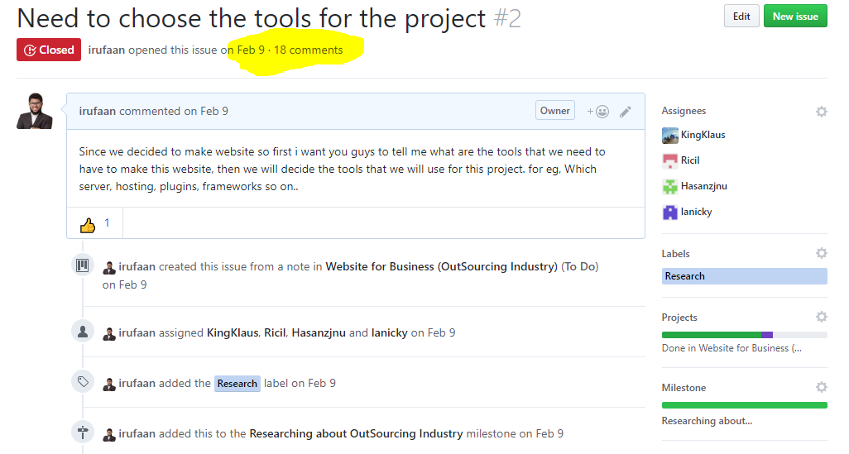

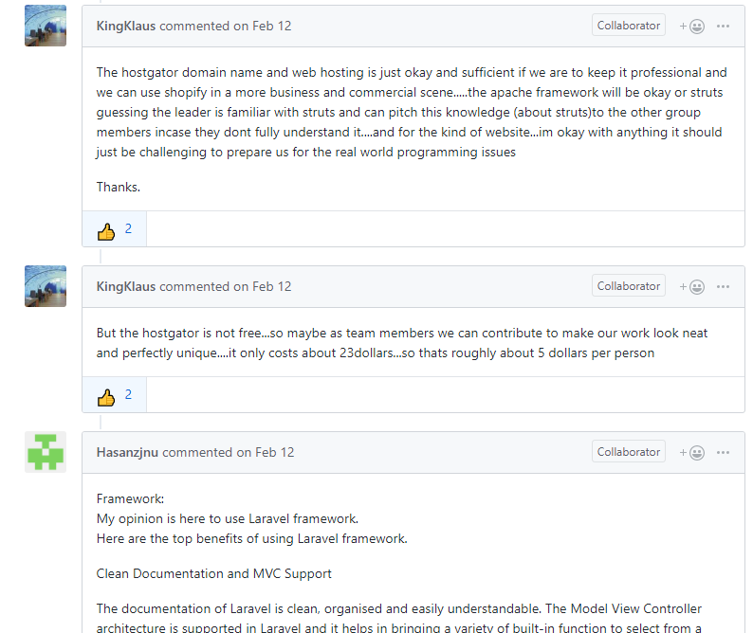

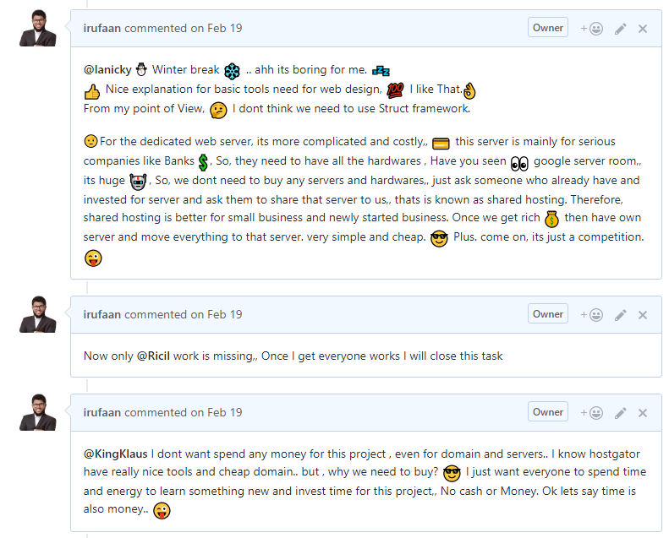

**Collection of data:**

We collect company information, product information, customer demands, customer information and all other relative information related to the market for our website. We collect data directly from those companies we are working with. We took their product information details and put in our website. For customer information we collect directly from the customers.

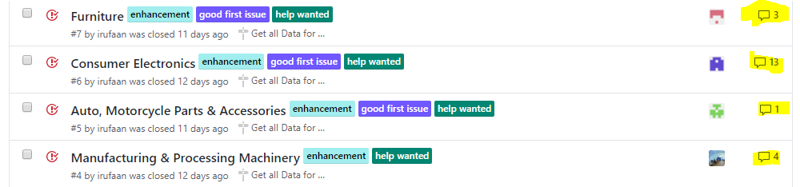

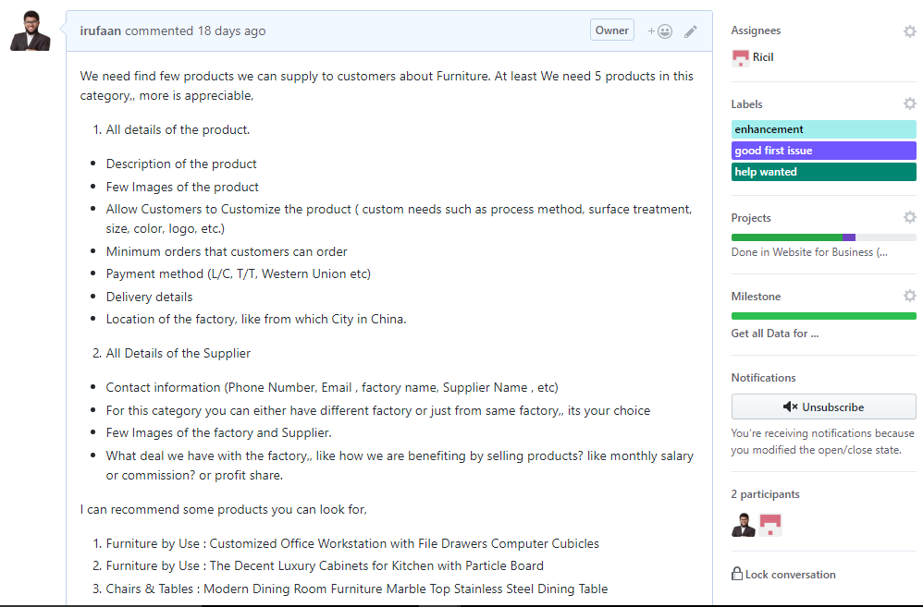

**Image and brand name selection:**

For image and brand name selection we took opinion from our team members. Every team member recommends their own choices and opinions. From those we select some unique images and brand name for our website.

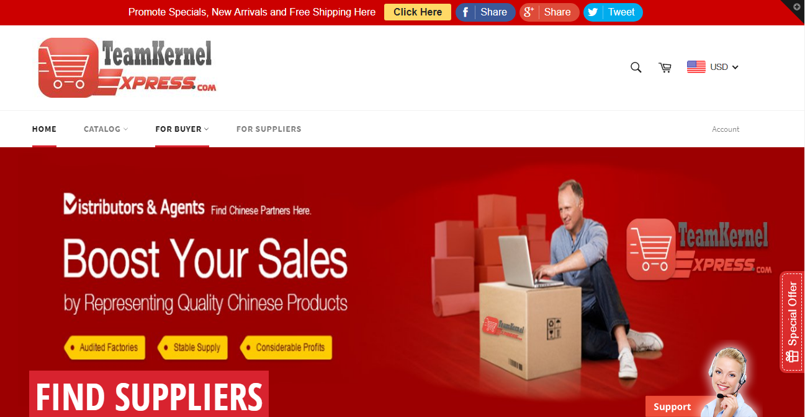

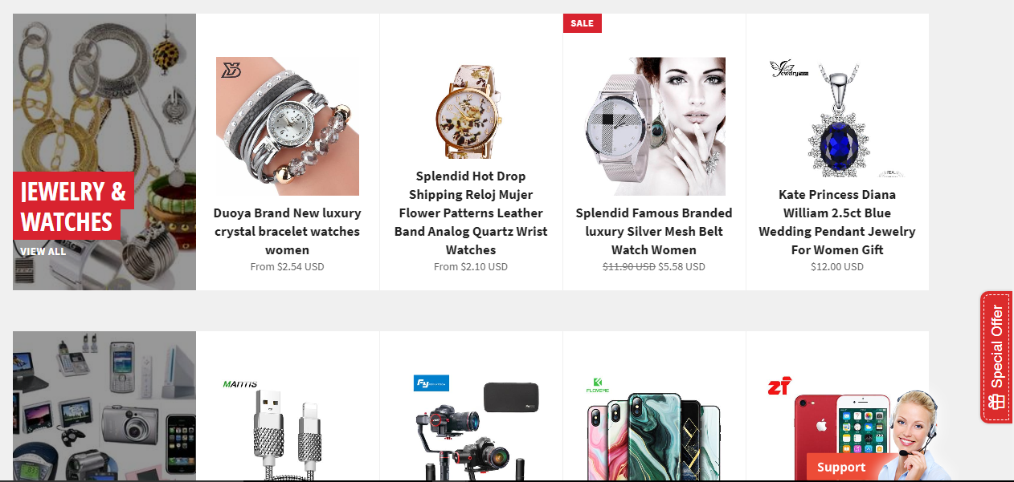

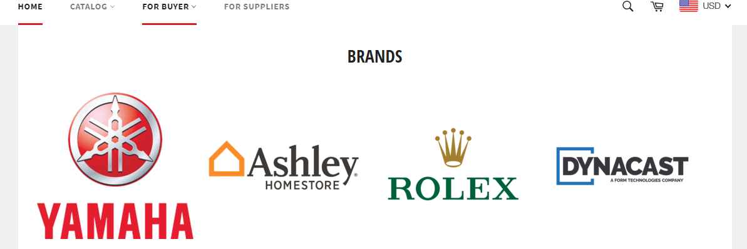

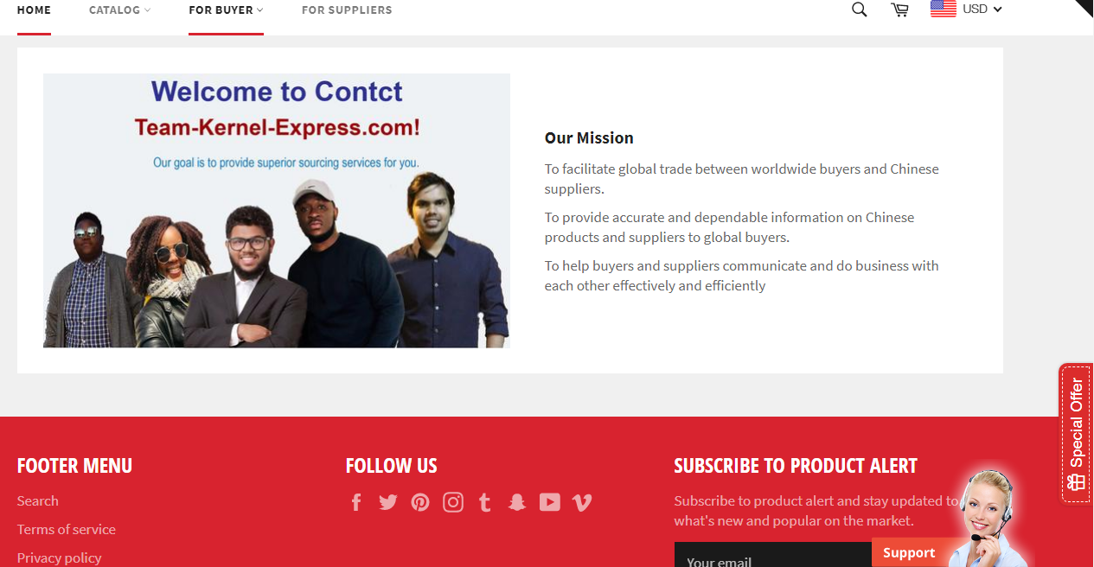

**Design and coding:**

We design the website to make it efficient and user friendly to our customers for better service. We used programming language such as Html, JavaScript, CSS, Python and Json for Data. We used Shopify Hosting Service as well as use some web Apps like Best Currency Converter for currency convertor and Easy Contact Form for Contacts.

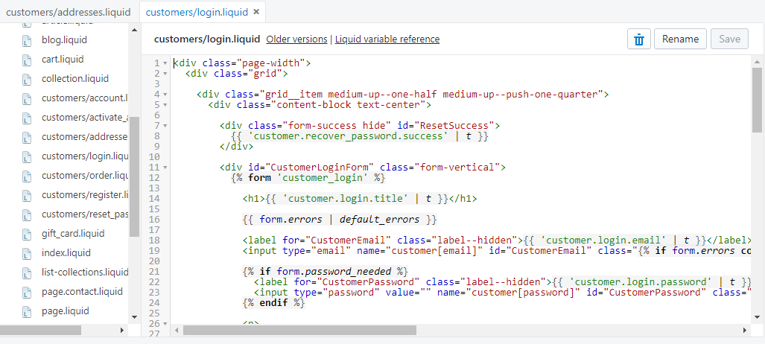

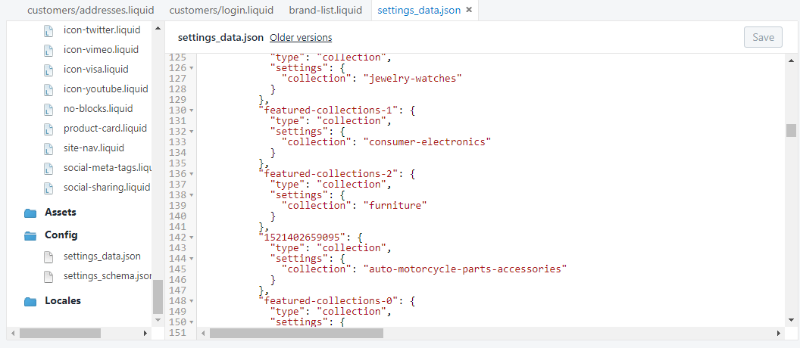

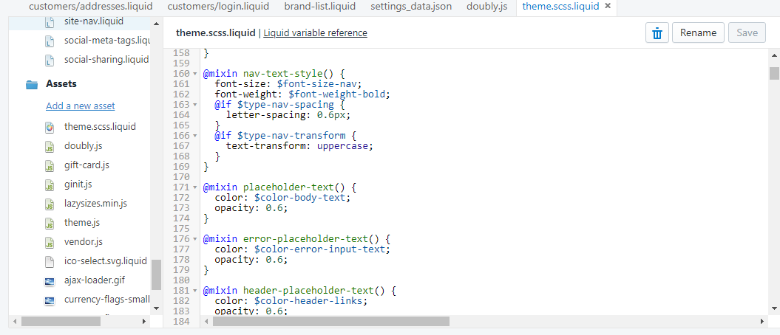

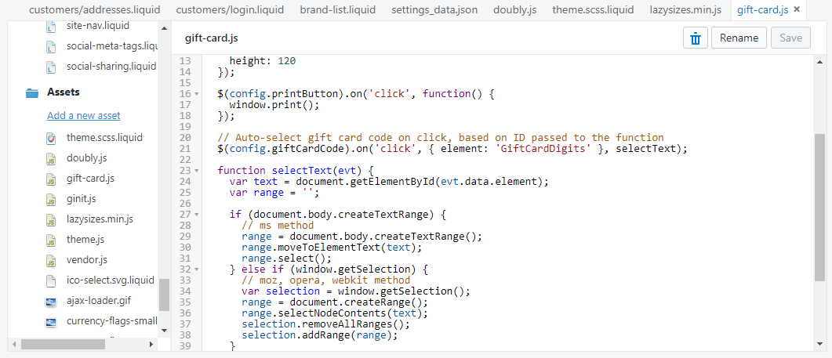

**Documentation:**

After finishing the website we start writing the documentation part such as Brief introduction, Background of self-selection and Business plan. We divided the work among our group members to make it easier.

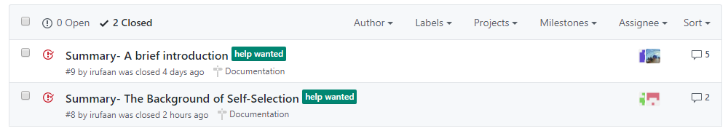

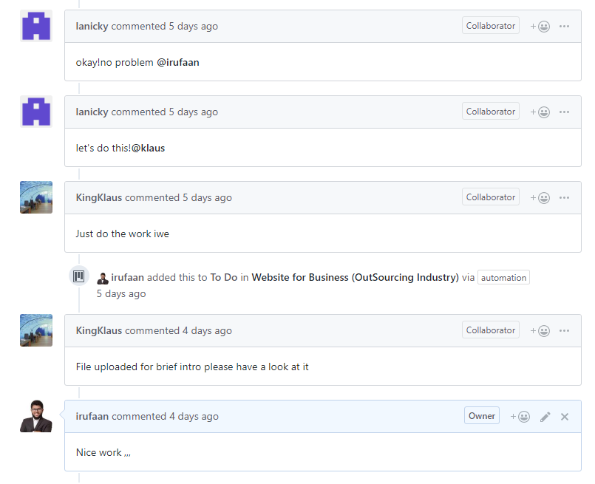

**Website overview:**

This is the website to facilitate global trade between worldwide buyers and Chinese suppliers.

To provide accurate and dependable information on Chinese products and suppliers to global buyers.

To help buyers and suppliers communicate and do business with each other effectively and efficiently.

### Services that can get to customers using this website

* Customers can get detail information about the products.

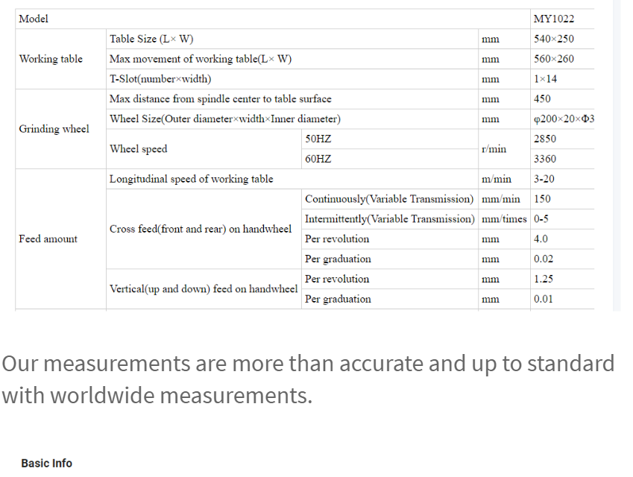

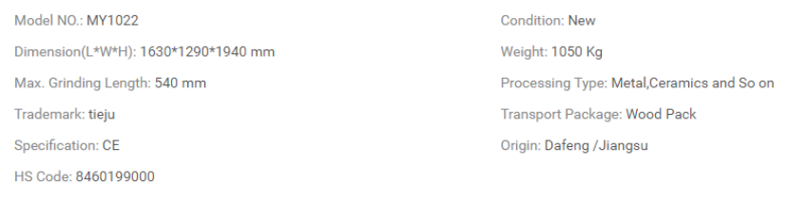

* Customers can get detail information about the company.

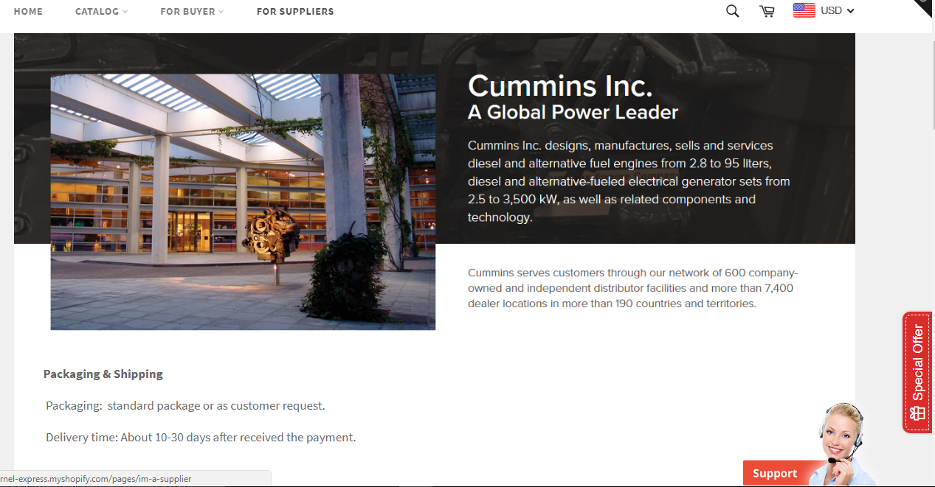

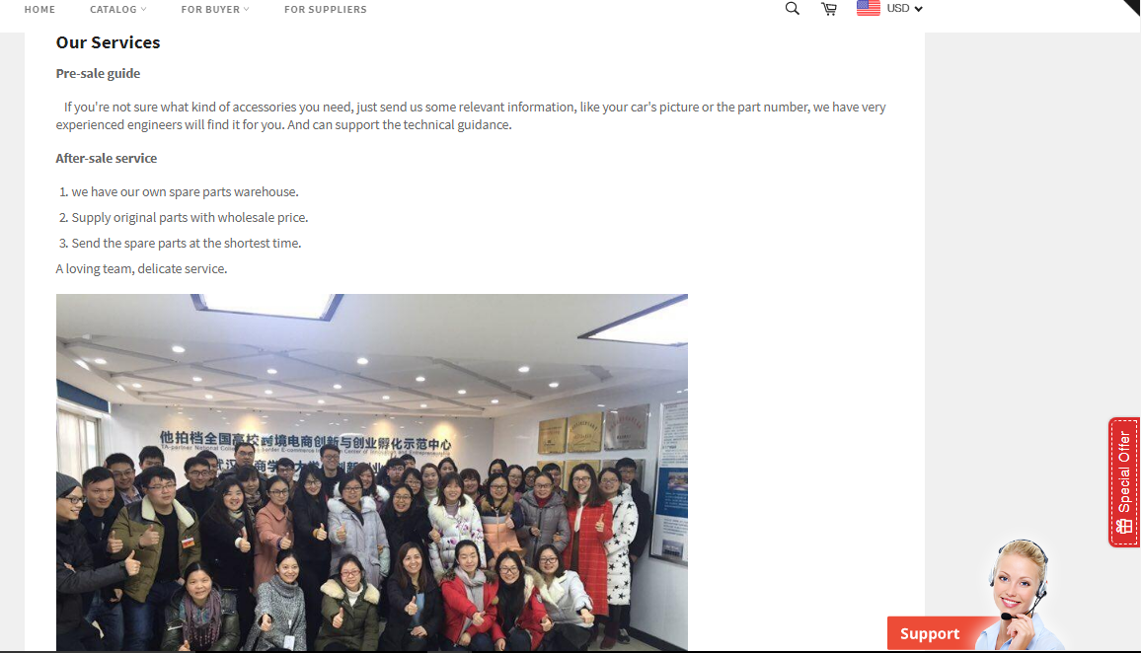

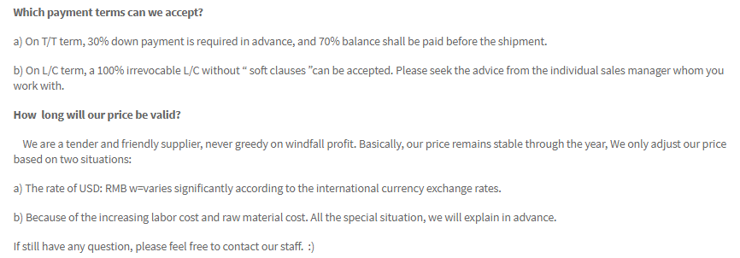

* In order to test the product before ordering in bulk quantity, Customers can buy sample product from the website

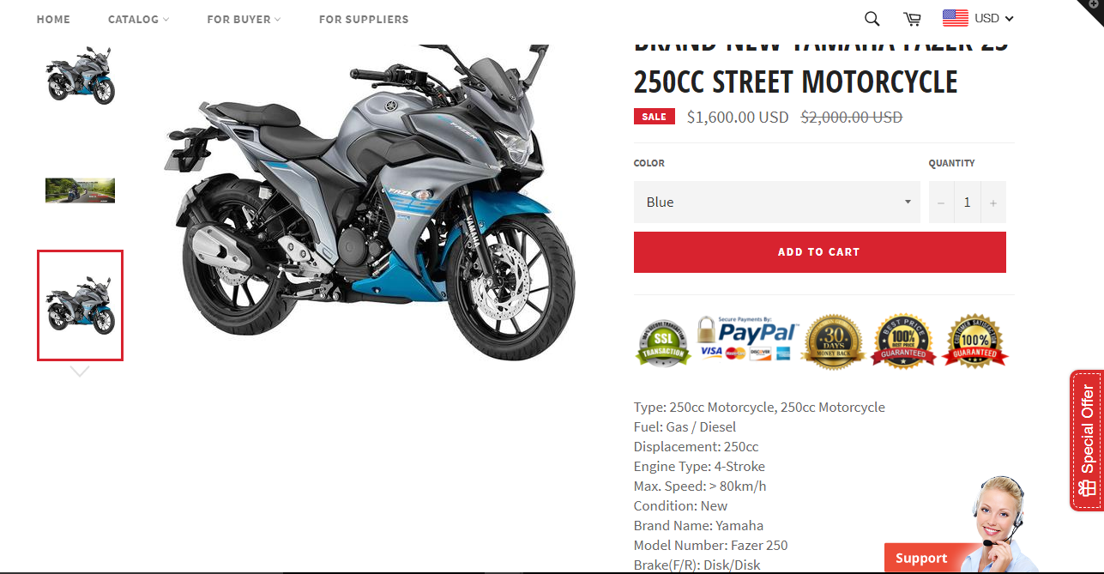

* If customer request to meet the company in China, we can arrange offline meeting

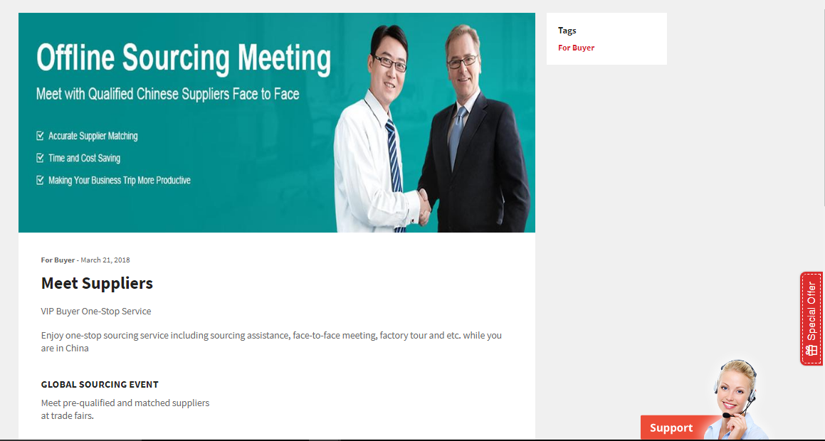

* Customers can customize the products.

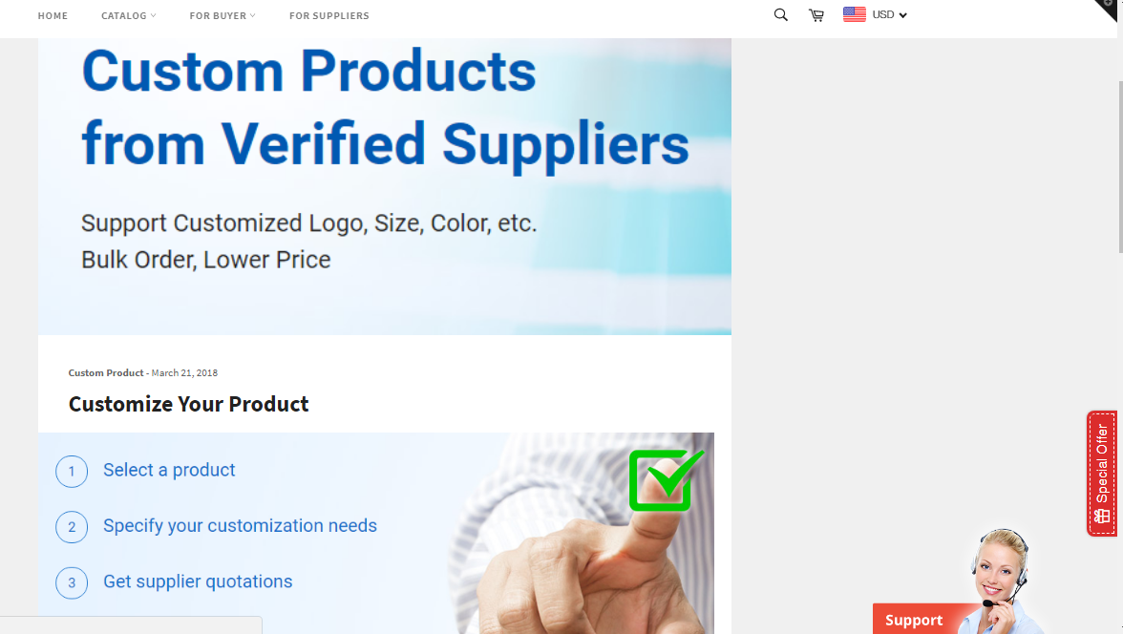

* We help customers to participate business fairs according to the seasons

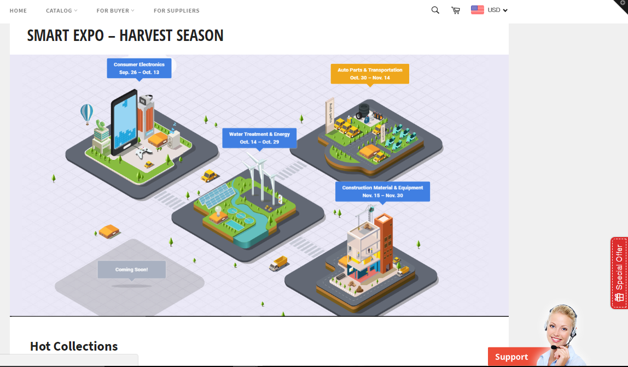

* Website can be translated to more than 100 languages.

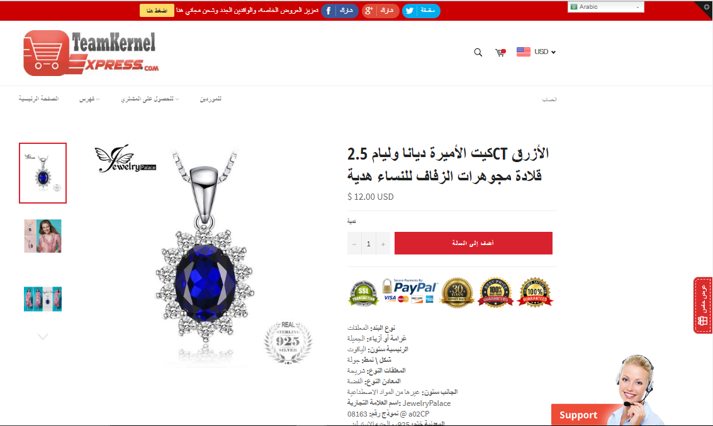

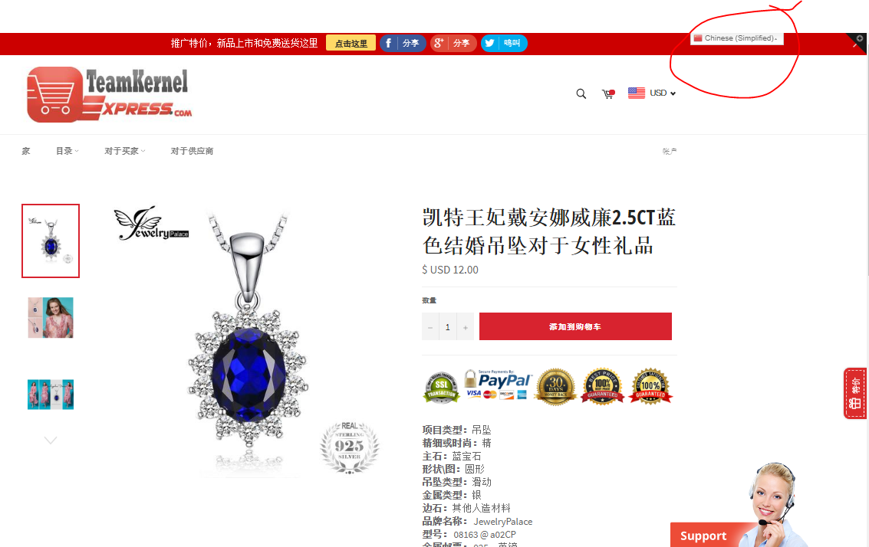

### Services that can get to Suppliers using this website

We also show suppliers the details of the available out sourcing requests. But only registered suppliers can contact to the customers. Because we don’t display customers contact details for free. First, Suppliers need to contact to us in order to access the customer contact details.

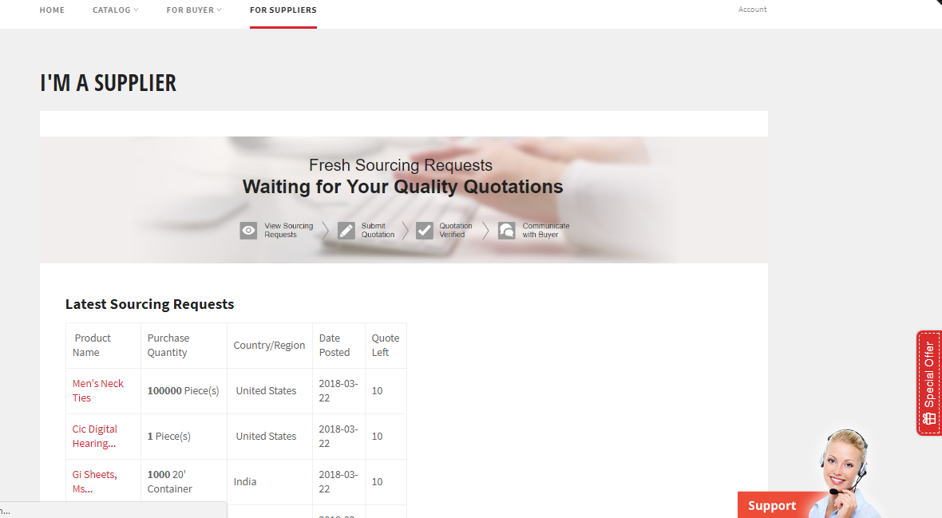

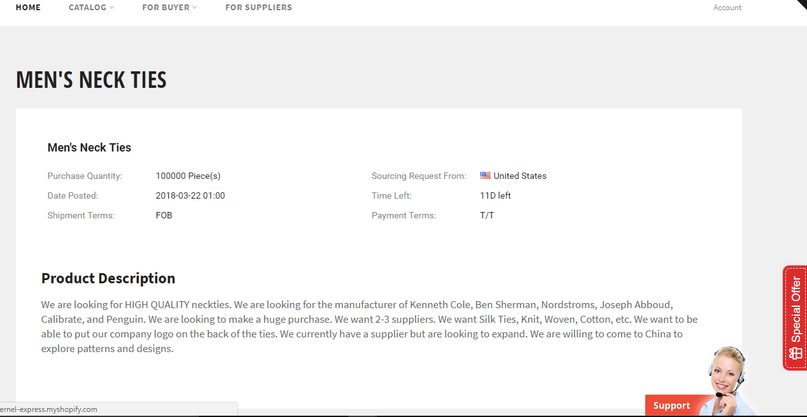

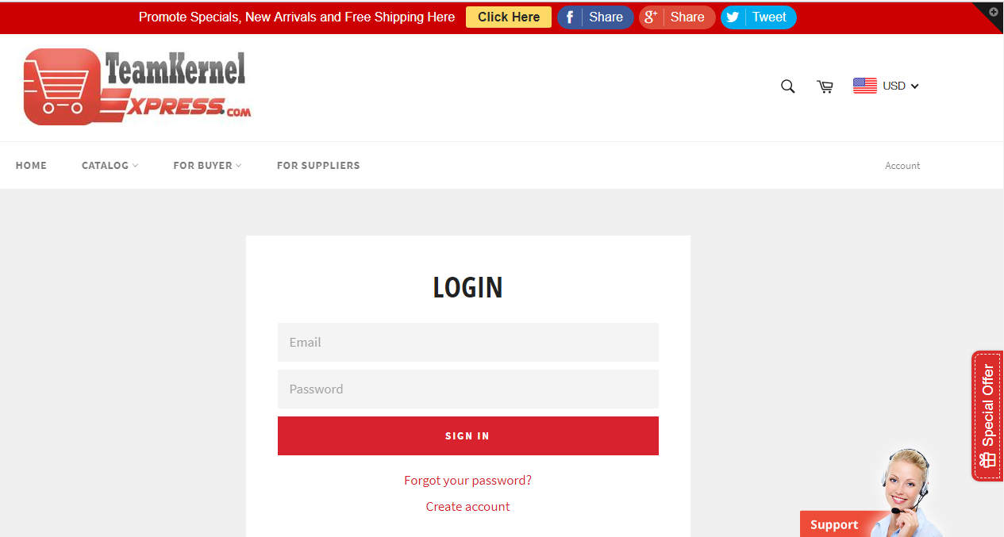

### Conclusion

One of the biggest advantages of outsourcing is cost savings. The lower cost of operation and labor, and reduction in overhead costs makes it attractive to outsource. By increasing productivity and efficiency, a business can be more successful, better-prepared for market challenges and have a streamlined cash flow.

At the end by everyone’s effort we successfully finish our desired work. It helps us to improve our outsourcing knowledge, E-Commerce business knowledge. It also helps us to improve our web developing skill, team management skill and a lot more.

THANK YOU.